

|  |  |  |  |  |
| --- | --- | --- | --- | --- |
| Year 12 Physics – Test 1 (Task 2)  **Motion** | | | | |
|  | | | | |
| Name: | | | | |
| **Time allowed**: 45 minutes + 5 mins reading time. | | | | |
| **Section** | Number of questions | Your Mark | Marks available | Percentage of Test |
| **Section One:**  Short answer | 5 |  | 18 | 39 |
| **Section Two**:  Extended answer | 4 |  | 21 | 46 |
| **Section Three:**  Comprehension  and data analysis | 1 |  | 7 | 15 |
|  | **Total** |  | **46** | **100** |

* Final answers should be given up to three significant figures and include appropriate units where appropriate. Questions containing the instruction "ESTIMATE" should be given two significant figures and include appropriate units where applicable.
* Scientific Calculators are allowed.
* No notes allowed.
* Formula sheet is provided.

**Section One:** Short answer

1. **(4 marks)**

Simon miscues a pool ball with sufficient velocity for it to jump the table and fall to the floor, as shown in the diagram below.

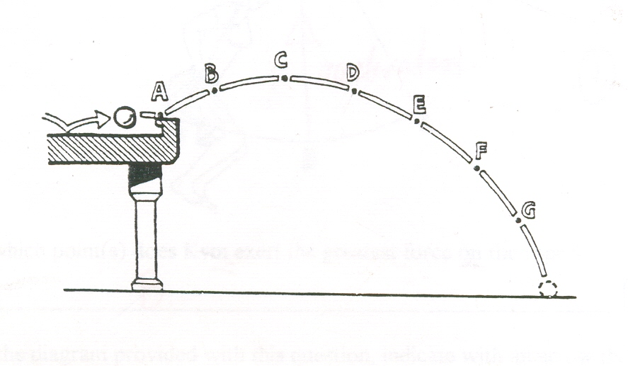

1. At which point(s), if any, will the horizontal velocity be zero?

(1 mark)

1. At which point(s), if any, will the pool ball have the same velocity as when it left the pool table?

(1 mark)

1. At which point or pair of points, if any, are the speeds of the ball equal?

(2 marks)

1. **(3 marks)**

Young Johnny and his brother Sam are playing a new game. Johnny rolls a large ball bearing along the top of a table with a constant velocity of 2.54 ms-1 while his brother pushes a small trolley along the ground directly below. The idea of the game is to get the ball bearing to land in the trolley after leaving the table. This occurs when the trolley and ball are in the position shown and the trolley is released 0.83 m away from where it will catch the ball bearing. Calculate the height of the table.

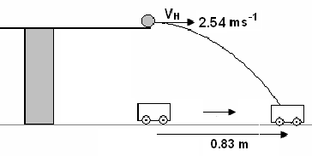

1. **(3 marks)**

The following shows a beach ball thrown from one person to another without air resistance.

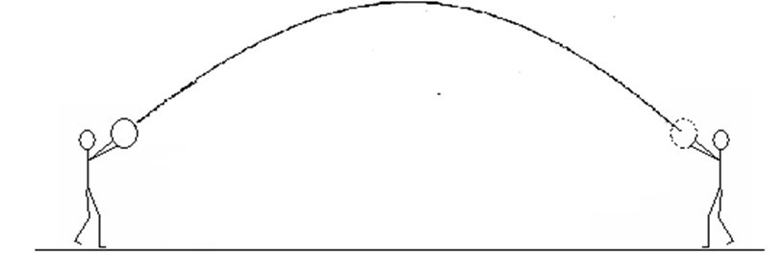

Draw the possible path of the beach ball with air resistance.

1. **(4 marks)**

The diagram below shows the path travelled by a shot-put, from A to D, after it has been thrown by a competitor from a height of 1.92 m.

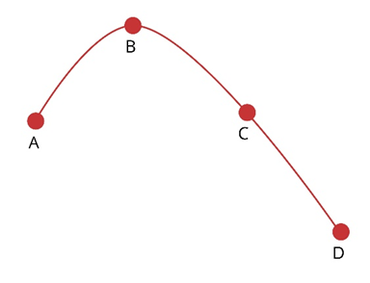

On the axes provided, sketch the vertical component of velocity against time as it travels from the competitor’s hand until it strikes the ground. On your graph mark the points A, B, C and D that correspond to these points on the curve. Other labels can be used to assist if needed.

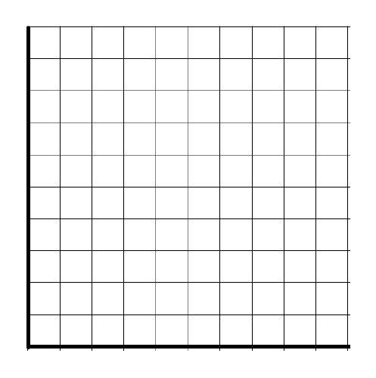

Velocity ($ms^{-1}$)

Time (s)

1. **(4 marks)**

A projected space station essentially consists of a circular tube that is set rotating about its centre (like a bicycle tube). The circle formed by the tube has a diameter of 1.10km. It is shown below. The circular tube rotates around a central axis so that the effect of gravity is created and people can walk around the outer edge of the station.

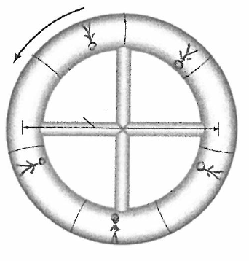

What must be the rate of rotation (revolutions per day) if an effect equal to the gravity experienced at the surface of the Earth is to be simulated?

**Section Two:** Extended answer

1. **(7 marks)**
2. The radius of a curved section of road is 35 m. At what angle should the road be banked to allow drivers to safely take the curve at the speed limit of 80 km h−1 and without needing to rely on the friction between the road and tyres? Support your answer with a labelled free body diagram to show the forces and their net force involved.

(4 marks)

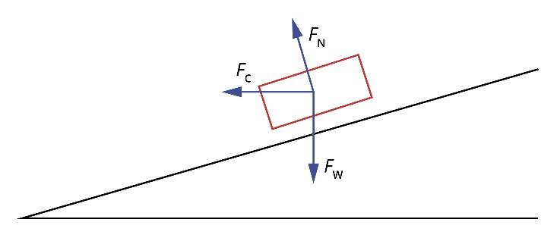

1. If the mass of the vehicle is doubled, how would this effect the maximum speed possible around the corner? Justify your answer using the formulae used in part a)

(3 marks)

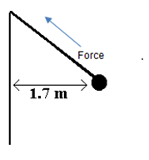

1. **(5 marks)**

A hammer thrower has gradually increased the speed of his hammer so that it completes ten revolutions in 22.0 s. The hammer of mass 7.26 kg may be considered to be moving in a horizontal circle of 1.70 m radius as shown right.

1. What is the speed of the hammer as it turns through the circle?

(2 marks)

1. What is the magnitude of the tension in the cable holding the hammer?

(3 marks)

1. **(9 marks)**

Thomas, who has a mass of 43.6kg, slides down the banister at his grandparents’ house. The banister makes an angle of 35º with the horizontal and provides a frictional resistance. The railing provides a frictional resistance of 110N.

1. Draw a labelled free body diagram of the above situation showing all the forces involved.

(3 marks)

1. What is Thomas’s net acceleration down the banister?

(4 marks)

1. How fast is tom moving at the bottom of the 5.00 m length of bannister, assuming he started from rest?

(2 marks)

**Section Three:** Comprehension and data analysis

1. **(7 marks)**

**The following information applies to parts a) through d).**

The data below was collected from an experiment in which a human cannonball of mass 80 kg was blasted towards the east from a cannon and landed in a safety net. The height of the net was equal to the launching height. The angle of launch was 45° and the initial speed was 28 m s**−1**. The human cannonball landed in the net exactly 4 seconds after being fired.

For all questions **use *g* = 10.0ms-2** and you may ignore air resistance.

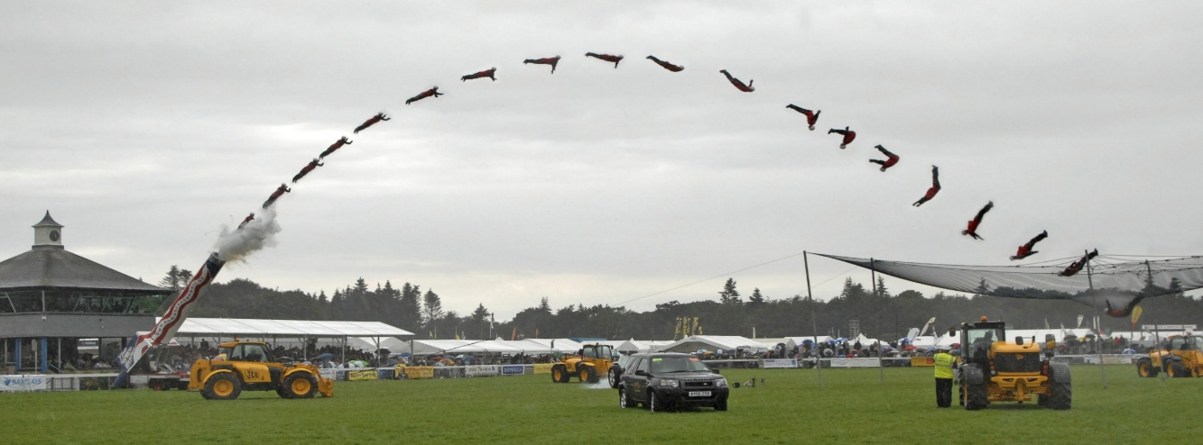

|  |  |
| --- | --- |
| **Time after launch (s)** | **Speed (m s−1)** |
| 0 | 28.0 |
| 1.0 | 22.4 |
| 2.0 | 20.0 |
| 3.0 | 22.4 |
| 4.0 | 28.0 |

**Acceleration (m s**

**2**

**)**

**Acceleration versus time**

0

0.5

1.0

1.5

2.0

2.5

3.0

3.5

4.0

4.5

1. On graph paper above, produce a graph of acceleration versus time for the human cannonball for the 4.0 s of motion. Use up as positive and ensure that your graph is appropriately labelled.

(2 marks)

1. Use vector components to determine the height above firing position after 2.5 s

(2 marks)

1. Calculate the speed of the human cannonball after 3.5 s.

(3 marks)

**End of Test**